**Pearls and Pitfalls: Resuscitation in Pulmonary Hypertension**

**Pathophysiology of Pulmonary Hypertension:**

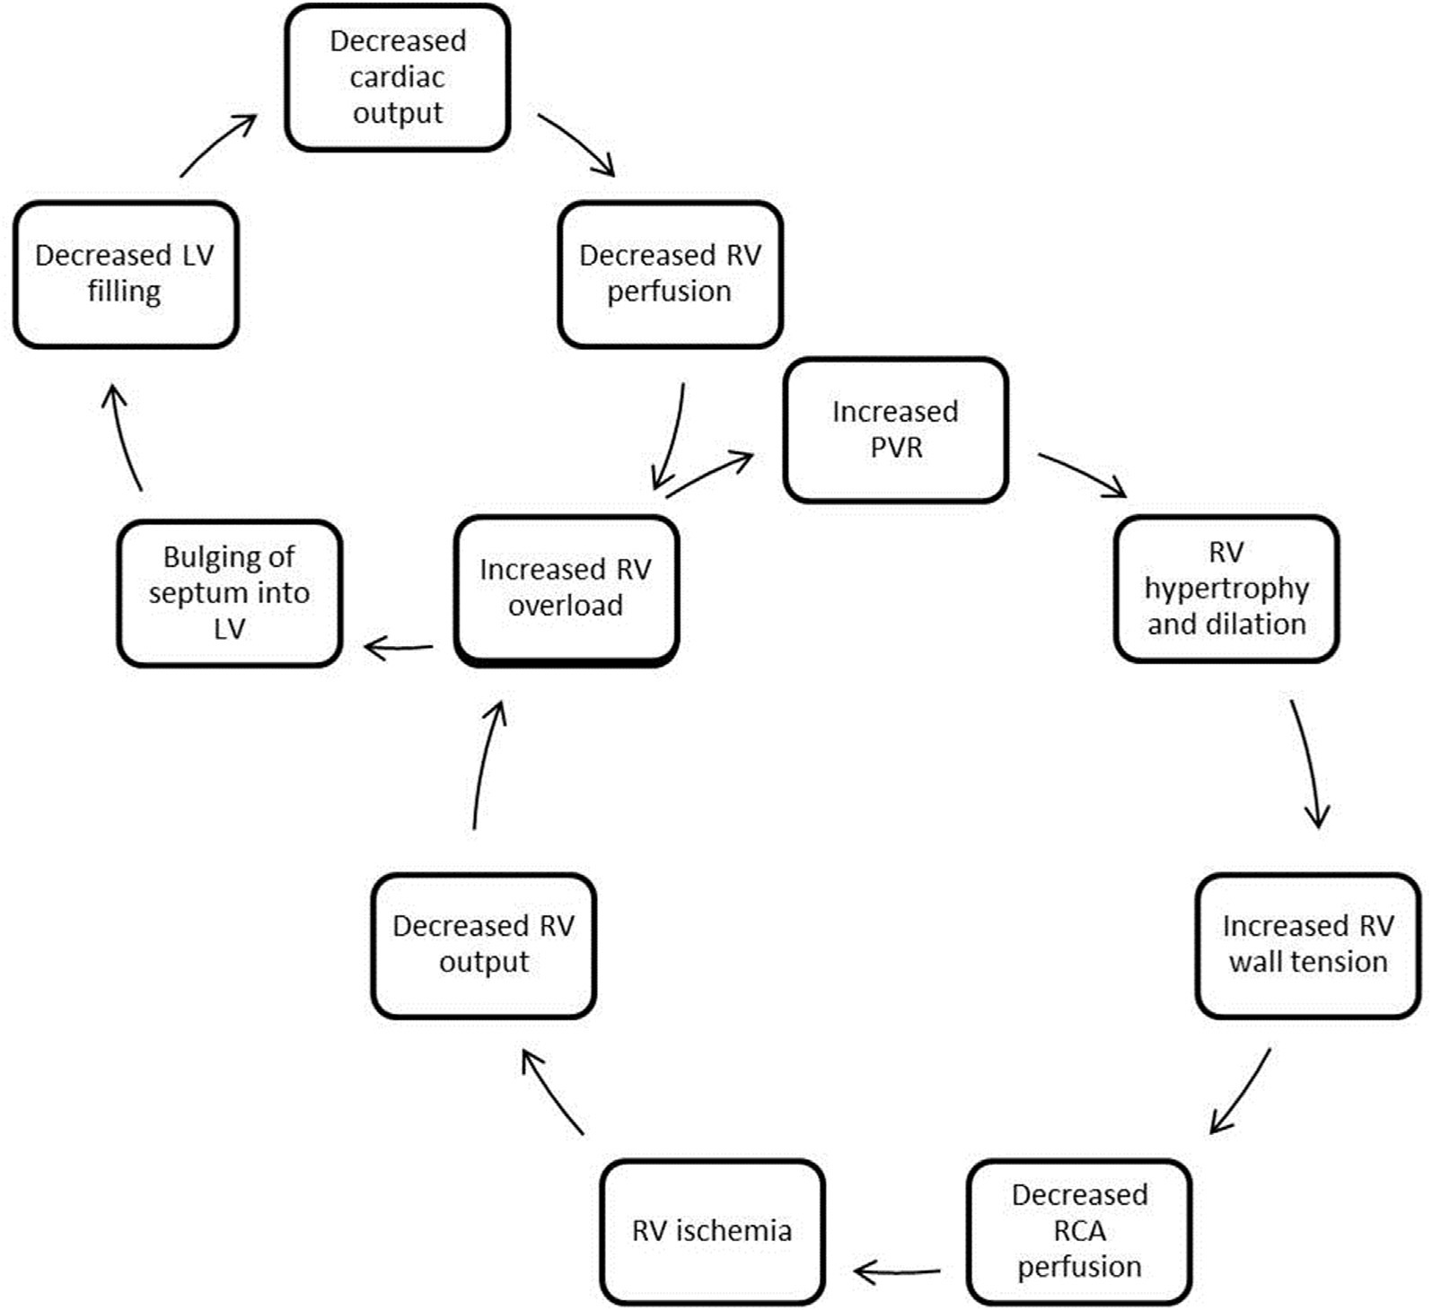

**Resuscitation:**

When resuscitating a patient in respiratory distress secondary to pulmonary hypertension, there is a delicate and dangerous balancing act to avoid right ventricle (RV) failure and hypoxia. The most important concept I would like to emphasize is that you cannot augment cardiac output (CO) in these patients, so you must avoid worsening pulmonary vascular constriction and hypotension.

The approach to airway is complex. Our usual go-to therapies of non-invasive ventilation (NIV) and intubation can cause cardiopulmonary collapse with little hope of adequately ventilation or regaining spontaneous circulation. We have to consider the changes in intrathoracic pressure that result from NIV and mechanical ventilation that may decrease preload and CO. And additionally, any transient hypoxia that occurs during intubation will further constrict the pulmonary vasculature and worsen CO. Even considering the medications that we use for intubation, one must realize they may worsen venous return to the heart and thus cardiac output and respiratory dynamics.

Fluid resuscitation can also be tricky, because overloading the RV is the primary cause of RV failure. If you think your patient is hypovolemic, consider small fluid boluses of 250cc with careful monitoring after each bolus. Conversely, systemic hypotension will worsen CO, so patients may need fluids.

As we all know, sedatives, narcotics, and anxiolytics can worsen respiratory drive and result in hypoventilation. Diuretics may improve RV function by reducing preload, but decreased preload also has the potential to worsen CO. In addition, it is not the best emergent treatment because these effects are delayed and may not occur until hours later. If you’ve stabilized your patient in the ED, you don’t want to potentially cause hemodynamic decompensation down the road. When selecting vasopressors, consider the etiologies of pulmonary hypertension. If they fall into the groups 2-5 categories (Include a table of the categories for reference), which encompass anything except primary pulmonary hypertension, norepinephrine is first-line. It seems that vasopressin may be the ideal pressor to use for group 1 patients.

Most previously diagnosed patients will be on continuous pulmonary vasodilators. These should never be discontinued, because rebound pulmonary hypertension will occur. And if a patient with history of pulmonary hypertension comes in with normal vital signs and without respiratory distress, but says he or she is on an infusion pump that has malfunctioned, consider this a life-threatening emergency, and while preparing for a difficult resuscitation, contact the pulmonologist.

Finally, consider contacting the closest ECMO (extracorporeal membrane oxygenation) site early. If you can stabilize these patients, this is a possible treatment options.

**Vasopressors:**

1. Norepinephrine is first line in groups 2-5. Its main benefits is that it helps maintain coronary perfusion, which is an issue with RV dilatation. It can slightly increase inotropy, but has slight alpha stimulation in the pulmonary vasculature, which is bad.
2. Phenylephrine should be avoided in pulmonary hypertension because it increases pulmonary vascular resistance.
3. Dobutamine increases tachycardia, decreases systemic vascular resistance causing hypotension, which is why it is a poor choice as a single agent.

**Other medications:**

1. Beta blockers and calcium channel blockers further impair right ventricular function. If patients arrive with new-onset atrial fibrillation, cardioversion should be strongly considered.
2. Vasodilators can worsen ventilation-perfusion matching. Left ventricle (LV) dysfunction (group 2 patients) may have worsening pulmonary edema when the pulmonary arteries are dilated, but they are useful for group 1, and maybe 4 and 5.
3. Inhaled nitric oxide promotes vascular smooth muscle relaxation, and because it is inhaled, it is limited to ventilated regions of the lung. It decreases pulmonary artery pressure and pulmonary vascular resistance, and increases venous return to the heart. Consider this as first-line therapy for a patient with respiratory distress. what is the evidence for this?
4. Prostacyclins cause pulmonary vasodilation, decreases in pulmonary artery pressure and pulmonary vascular resistance. Endothelin receptor antagonists increase cardiac output and decrease pulmonary artery pressure. And phosphodiesterase-5 inhibitors block degradation of cyclic GMP, decrease pulmonary artery pressure, and increase cardiac output. This category of medications are common in outpatient regimens.

#### Reference:

Wilcox, Susan R. et al. Pulmonary Hypertension and Right Ventricular Failure in Emergency Medicine. *Annals of Emergency Medicine*. Volume 66, Issue 6, 619 – 628.