**Dear Students,**

**Prior to your shelf exam, you must ensure that your device is compatible with the NBME web exam. Please follow the instructions below for your device to ensure your computer will correctly work, MAC users please update your mac device prior to the exam. NBME has provided a MAC update for their webpage (check the student website for MAC update links) Minimum computer requirements:**

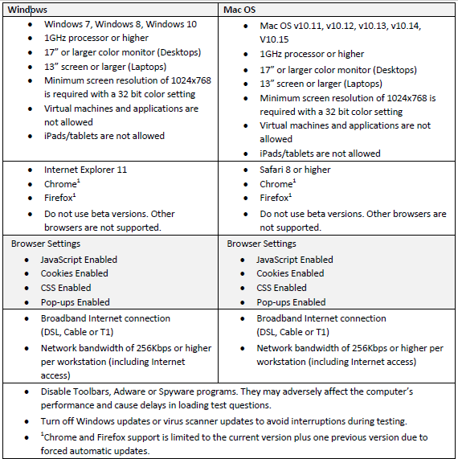

**After you have configured your device, you must then certify it:**

1. Make sure there are **no recording programs running on your device**before doing workstation certification and before beginning the examination on test day.  Zoom and Teams must be logged off and closed.
2. Go to http://wbt.nbme.org/exam and follow the on-screen instructions to run the Secure Browser.  Select the **REMOTE PROCTORING PROGRAM**
3. Select the **Workstation Certification**icon.
4. Select the Examinee Personal Laptop Certification link. The utility will test the laptop for compatibility with web-based testing.
5. **NOTE: Only make TWO (2) attempts.**If successful, you will be prompted to launch a sample exam as the final step.

**If you are successful** and are able to take the mock exam, please send an email to your clerkship coordinator with the **subject line: “My Device is ready for the NBME”, before noon on the last Tuesday of the rotation.**

**In the event that your computer fails the precertification, or you receive the error message below, DO NOT attempt to troubleshoot the problem on your own. Instead, send an email to help@downstate.edu with the subject: Problem with device certification for NBME on DATE). In the body of the message, please include your name, SID, phone number and clerkship.  Technical support will contact you soon after receiving your request.**

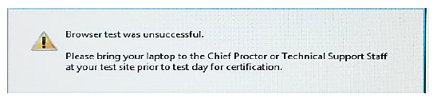

After you have certified your device, please follow the Qualtrics link to the honor code provided for this exam to let us know that you were successful!