**Logging Duty Hours**

Students are required to log duty hours in New Innovations on a weekly basis, at minimum, over the duration of all core clerkships. The logging procedure is simple, fast and straightforward, and we consider it pivotal in your professional developmental as well.

You may log daily, or at a different frequency, as long as you have logged the complete preceding week of duty hours by 6:00 PM each Monday. The preceding week is considered Sunday through Saturday. All required clinical and didactic hours must be logged. Study time should NOT be logged. Furthermore, a half hour must be rounded to a full hour.

As you may be aware, the ACGME resident duty hours restrictions emanated from a tragic patient outcome resulting in the New York State Department of Health Code, Section 405,  known as the Libby Zion Law, and the Bell Commission. These regulations were generated as a patient safety measure, but have an important role in preserving wellness among medical trainees as well.  Both student and patient safety are our enduring priorities.

Thank you for your cooperation in fulfilling this important responsibility,

Instructions on how to log work duty hours in New Innovations:

1. Go to Work Hours > Log Hours
2. Select a student
3. Put the cursor on the cell that represents the ﬁrst hour worked
4. Drag the cursor to the last cell that represents the hours worked
5. Click Save

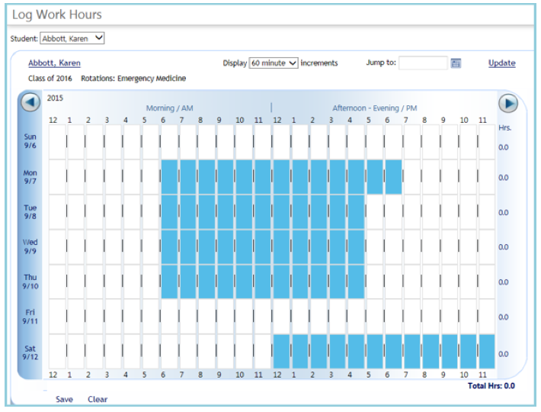

ADDITIONAL NOTES:

- The logging grid defaults to Sunday through Saturday of the current week.

- Use the 'Jump to' date box to go to another week and click Update

- Total hours for the week are noted at the bottom right of the grid

- Hours cannot be logged for the future