[**MMC Student Page**](https://www.maimonidesem.org/students/overview/)   
(MMC Website: https://www.maimonidesem.org/students/overview/)

**First Monday of Rotation:**

* 10:00am - Come to the Brownstone Office at 965 48th Street for Orientation. One of our senior residents will be available to answer questions. The admin resident will go over how to use our Electronic Medical Record system: SCM. You will also get a tour of the ED.
* 10:30am - Pick up scrubs from the Laundry Department if needed. You should receive instructions for this from Tina.
* Feel free to get lunch in the neighborhood if you do not have a shift after.
* 12:00pm- Intro to US course in the Simulation Lab

**Clerkship Preparation:**

* Before the **First Tuesday Small Group**, please review the “*Required”* material under the Curriculum Page on the website. (Maimonides Clerkship, Communication in the ER, and EKG Interpretation).
* Make sure to read the **Clerkship Manual** - it will answer almost all your questions about the rotation, including schedules, non-clinical responsibilities, patient logs and grading.

**ED Ultrasound course.**

* The **First Monday** of the block (1/4) there will be **an Intro to Ultrasound Course** in the SIM lab. To prepare for the US Lab, please watch the following videos before your course: (don't worry, only 5 min each)
  + - [http://5minsono.com/fast/](https://urldefense.proofpoint.com/v2/url?u=http-3A__5minsono.com_fast_&d=DwMFaQ&c=djx4x_Lu5jS1_mKMB7WBGhXdIwpne1KOnJAaisGB74Q&r=nDceMgWKas-5pTrepMS0j2LEKbRDc8wUAZCatICAMU8&m=-wDLcQX5BroNqvFreU71sj-6SLjB9gAbe7vNPisp410&s=cvCJlOXtnxZZHjW3k7Avrn2t7pvLeRyXo-XRlnElLKk&e=)
    - [http://5minsono.com/efast/](https://urldefense.proofpoint.com/v2/url?u=http-3A__5minsono.com_efast_&d=DwMFaQ&c=djx4x_Lu5jS1_mKMB7WBGhXdIwpne1KOnJAaisGB74Q&r=nDceMgWKas-5pTrepMS0j2LEKbRDc8wUAZCatICAMU8&m=-wDLcQX5BroNqvFreU71sj-6SLjB9gAbe7vNPisp410&s=IlejZIQSWmGdnNVh-v0kAhwCihek4nCfcRqi7WIEf5E&e=)
    - [http://5minsono.com/heart_views/](https://urldefense.proofpoint.com/v2/url?u=http-3A__5minsono.com_heart-5Fviews_&d=DwMFaQ&c=djx4x_Lu5jS1_mKMB7WBGhXdIwpne1KOnJAaisGB74Q&r=nDceMgWKas-5pTrepMS0j2LEKbRDc8wUAZCatICAMU8&m=-wDLcQX5BroNqvFreU71sj-6SLjB9gAbe7vNPisp410&s=NsN5k_7Nf7OILbgG22QTlFYsmeT_8BkwrRfo1Eb-cqE&e=)
    - [http://5minsono.com/hydro/](https://urldefense.proofpoint.com/v2/url?u=http-3A__5minsono.com_hydro_&d=DwMFaQ&c=djx4x_Lu5jS1_mKMB7WBGhXdIwpne1KOnJAaisGB74Q&r=nDceMgWKas-5pTrepMS0j2LEKbRDc8wUAZCatICAMU8&m=-wDLcQX5BroNqvFreU71sj-6SLjB9gAbe7vNPisp410&s=IGs-CwhU-8YGgcXHffB27-Uyr63Uv_8iX3yXjAMuy_U&e=)
    - [http://5minsono.com/gb/](https://urldefense.proofpoint.com/v2/url?u=http-3A__5minsono.com_gb_&d=DwMFaQ&c=djx4x_Lu5jS1_mKMB7WBGhXdIwpne1KOnJAaisGB74Q&r=nDceMgWKas-5pTrepMS0j2LEKbRDc8wUAZCatICAMU8&m=-wDLcQX5BroNqvFreU71sj-6SLjB9gAbe7vNPisp410&s=mbHNV_Bzt8gXWsN36yZPQTYfQiMjbD9wHNLMJTXl1dg&e=)
    - Here is a reference sheet with all the important numbers: [https://drive.google.com/file/d/0Bz4veKgbIVMDdlBIN0N0WU5tZEE/view?usp=sharing](https://urldefense.proofpoint.com/v2/url?u=https-3A__drive.google.com_file_d_0Bz4veKgbIVMDdlBIN0N0WU5tZEE_view-3Fusp-3Dsharing&d=DwMFaQ&c=djx4x_Lu5jS1_mKMB7WBGhXdIwpne1KOnJAaisGB74Q&r=nDceMgWKas-5pTrepMS0j2LEKbRDc8wUAZCatICAMU8&m=-wDLcQX5BroNqvFreU71sj-6SLjB9gAbe7vNPisp410&s=evPEbLBs7gF4odkxXjL40ja5nYuazj4J823Je2td5nA&e=)

**Shift Schedule:**

* Your shift schedule will be posted on the website (under Current Students): <https://www.maimonidesem.org/students/current-students/>
* The Key is on the right hand side listed by your initials

**Weekly Didactic Schedule:**

* Scroll down on the Medical Student “Current Students” Page. We will notify you by email if there are any major changes.

** **This is different for the PEM rotation as noted above**  
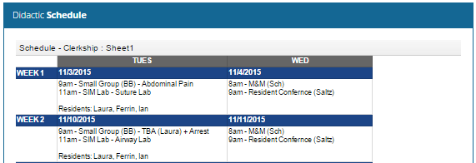

**Small Group / SIM Preparation each week:**

* **Each week**, review the required SIM Lab References under *Curriculum - SIM Lab References.*The topic each week can be found on the *Didactic Schedule*  
    
  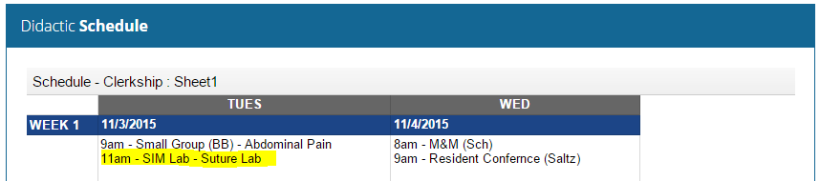

Note: At this time, the *Small Group Topics* are for *reference only*, you may choose to review them before/after small group / SIM or to help you study for exams.