EKG Small Group Exercises (Answer Sheet)

**Question One:**

A 25 year old F comes in with intermittent stabbing chest pain that lasts a few seconds at a time and is worsened with lying flat.

1. **Provide a Comprehensive Interpretation of her EKG**  
   (Hint: Rate, Rhythm, Axis, Intervals, QRS Complex, P-waves, T-waves, ST Segments, Q waves)

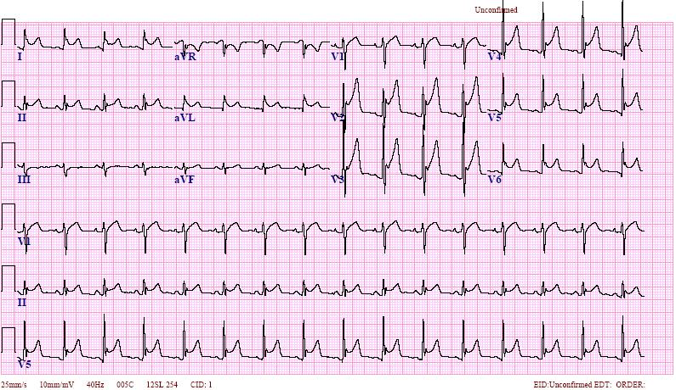

1. **What are the classic (early) EKG findings for this condition?**
2. **What are potential causes of this condition? What would be your work-up in the ED?**
3. **What is the ED management for this patient?**
4. **What other common EKG finding in young otherwise healthy people can be confused for pericarditis?**

**Question Two:**

A 57 year old man with a history of smoking, diabetes and hypertension presents with chest pain for the past one hour that started at rest and is persistent. It radiates to his right shoulder and he’s feeling short of breath and light-headed His blood pressure at triage is 110/70.

1. **Define the Acute Coronary Syndromes**:
2. **What are the (fundamental) STEMI Criteria?**
3. **Interpret his EKG**

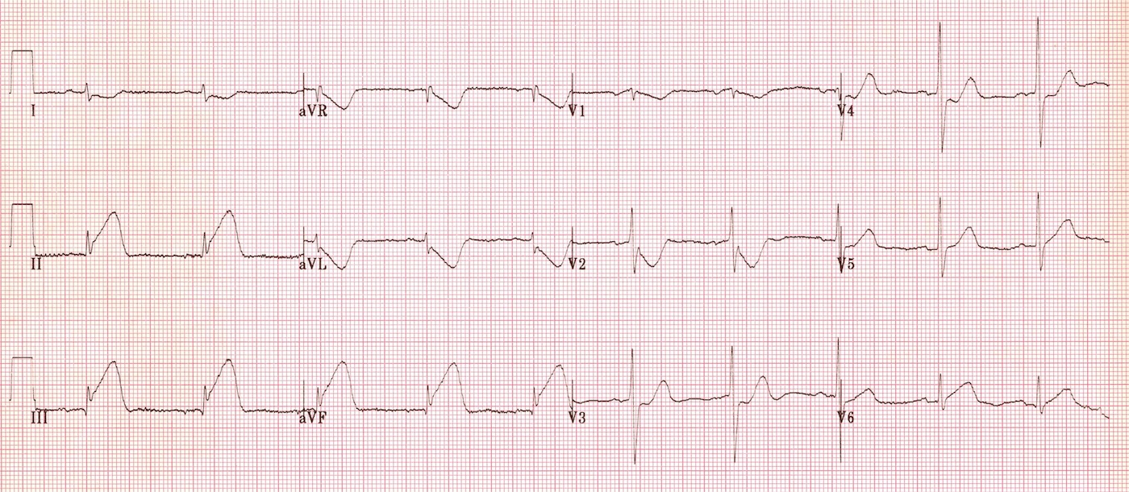

1. **What is the ED management for the patient with the above EKG?**

**Question Three**

A 64 year old woman with history of diabetes, smoking and hypertension presents with shortness of breath. Her initial blood pressure is 240/120. She is diaphoretic and unable to speak. After stabilization with BiPap and a nitroglycerin drip, you obtain an EKG.

* 1. **Interpret her EKG**

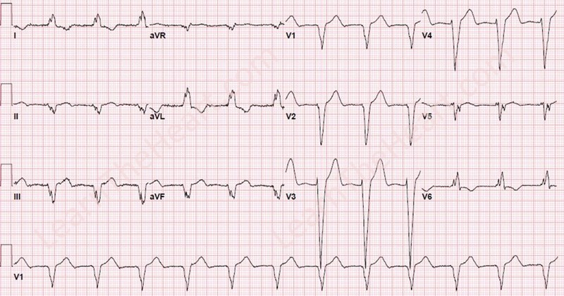

* 1. **Describe the criteria you might use to evaluate whether this is a STEMI or not.**
  2. **Discuss the difference between “right and left” of this condition?**
  3. **The patient is visiting the country and you have no prior EKG for her; what is your management?**

**Question Four**

A 60 year old woman who reports no past medical history comes in with shortness of breath and palpitations. Her blood pressure is 140/80.

1. **Interpret her EKG**

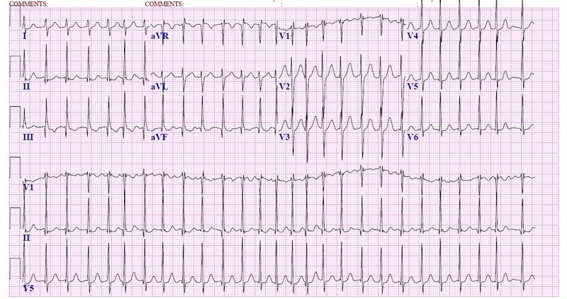

1. **What are the key EKG features of this condition?**
2. **What are some of the causes of this condition?**
3. **Describe the general ED and inpatient management of this condition.**
4. **How would your management be different if the patient was having crushing chest pain and/or hypotension?**
5. **How would your management be different if the rhythm was regular?**

**Question Five**

A 55 year old M with a history of smoking, hypertension, diabetes, and a prior MI with one stent presents with shortness of breath, lightheadedness, and chest discomfort. His blood pressure is 120/80.

1. **Interpret his EKG**

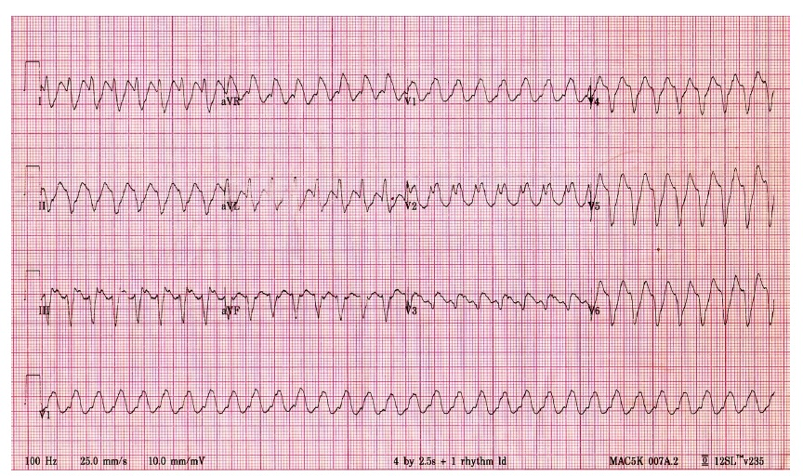

1. **What are the key EKG features of this condition?**
2. **What are the most common causes of this condition?**
3. **What else is in your differential for EKG wide complex tachycardia?**
4. **What is the ED management for this patient?**