**Question Six**

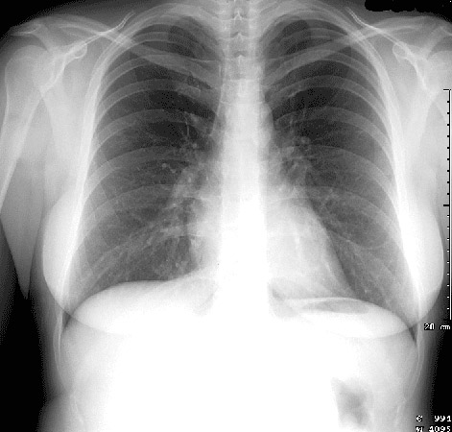

1. Describe a systematic way to read chest radiographies, using the above Chest XRAY as an example**.**
2. What type of Chest XRAY is this (AP vs PA) and how can you tell?
3. Identifying the following structures:
   1. Manubrium, Superior Vena Cava, Right Main Bronchus, Horizontal fissure, Right Atrium, Right and Left Oblique Fissures, Inferior Vena Cava, Diaphragm, Liver, Gastric bubble, Aortic Arch, Pulmonary Trunk, Left Main Bronchus, Left Atrium, Left Ventricle, Costo-phrenic angles

**Question Seven**

A 60 year old M is found down on the ground. He is tachypneic and tachycardic to 110. His blood pressure is 130/70. His O2 sat is 90%.

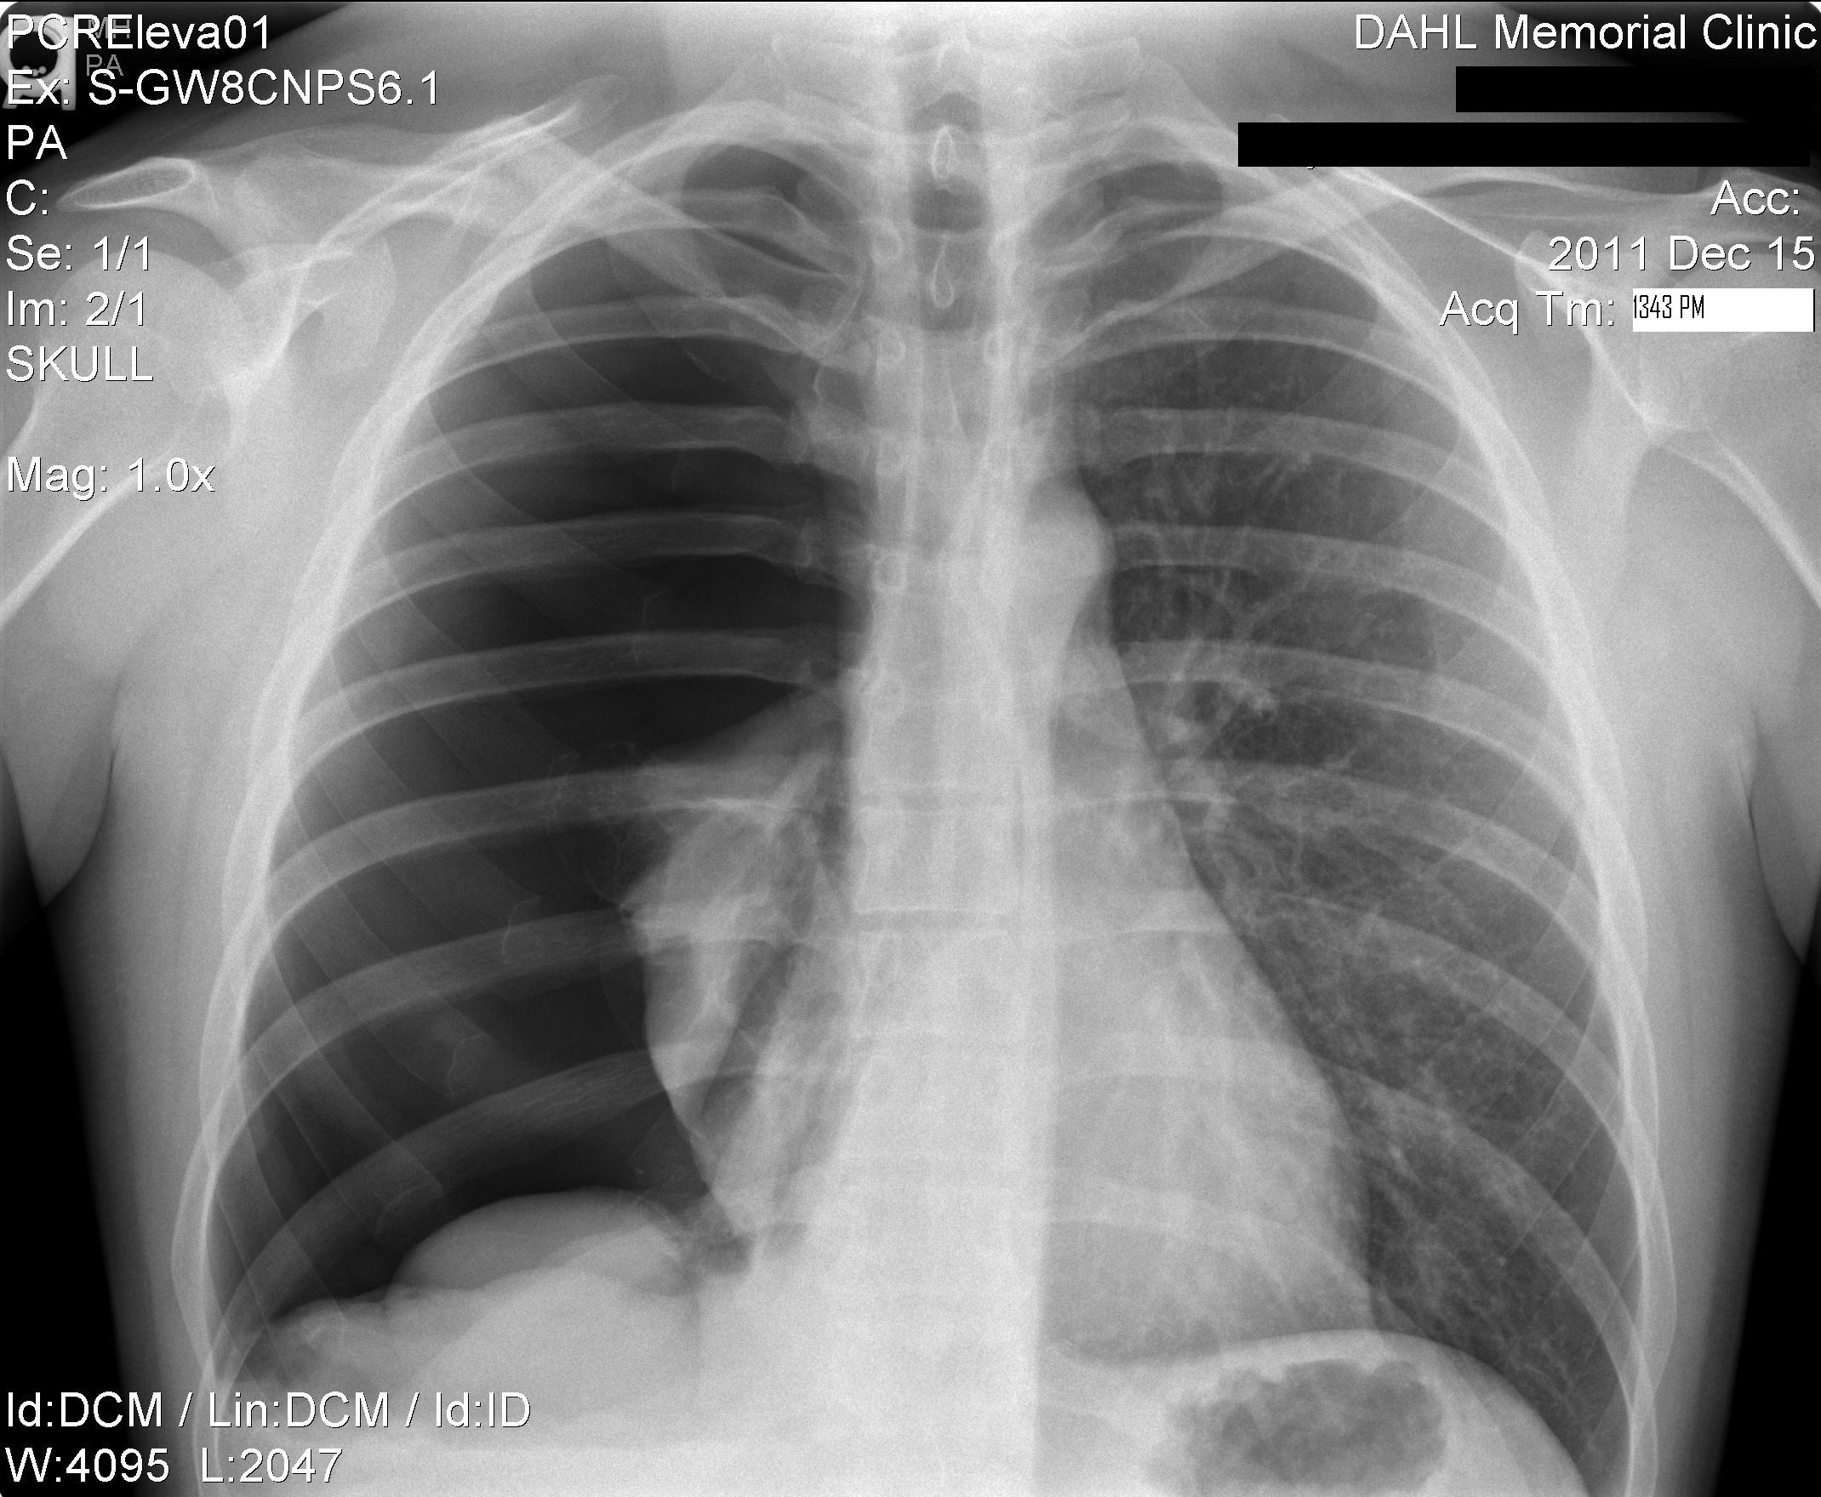

1. Interpret the chest xray.
2. Why might this diagnosis occur spontaneously (non-traumatic)?
3. What are the treatment options if it occurs spontaneously and when would you use each treatment?
4. What other imaging modalities can be used & when should you use them?

**Question Eight**

This is a 60 year old man found down, altered, and in moderate respiratory distress.

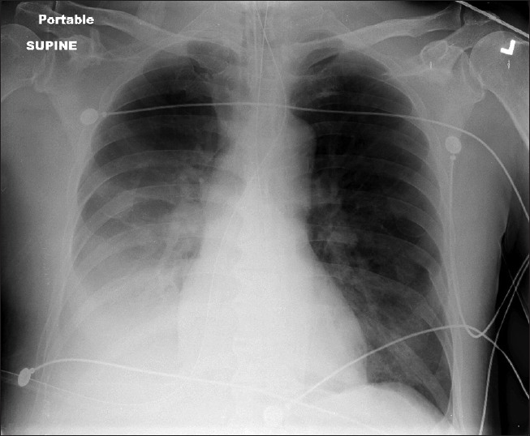

1. Interpret this Chest XRAY and diagnose the reason for this patient’s chest pain and/or shortness of breath.
2. What are possible etiologies to this patient’s condition? Briefly discuss treatment considerations.

**Question Nine**

This is a 70 year old woman in moderate respiratory distress.

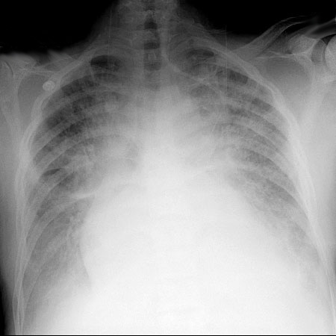

1. Interpret this Chest XRAY using a systematic approach and diagnose the reason for this patient’s chest pain and/or shortness of breath.
2. What other imaging modalities can be used & when should you use them?

**Question Ten**

This is a 35 year old M with chest pain. His vitals are normal except for an BP of 180/120.

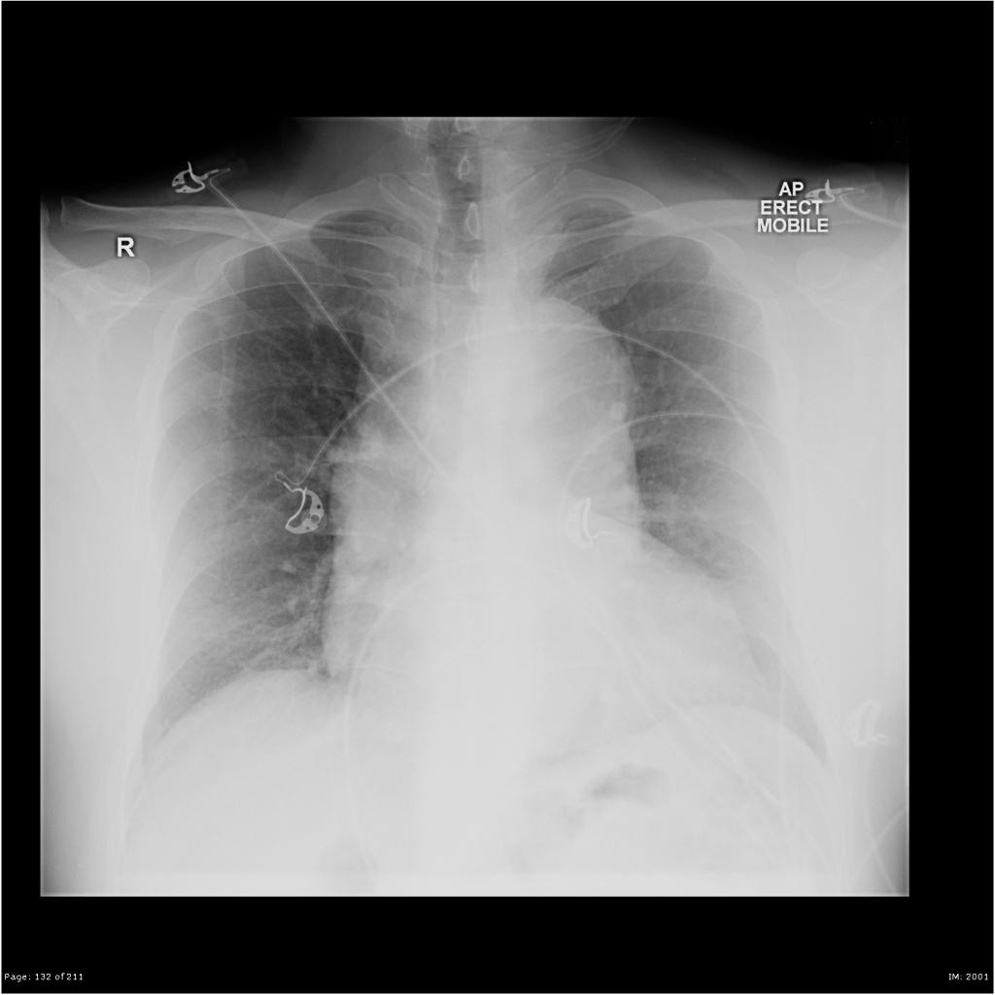

Case courtesy of Royal Melbourne Hospital Respiratory, Radiopaedia.org, rID: 21989

1. Interpret this Chest XRAY using a systematic approach and formulate a differential diagnosis for this patient’s chest pain and/or shortness of breath.
2. What are your next steps in evaluation and/or treatment?
3. Discuss emergency department management of the most dangerous diagnosis.