Chest Pain Workshop Assignments

Question 1:

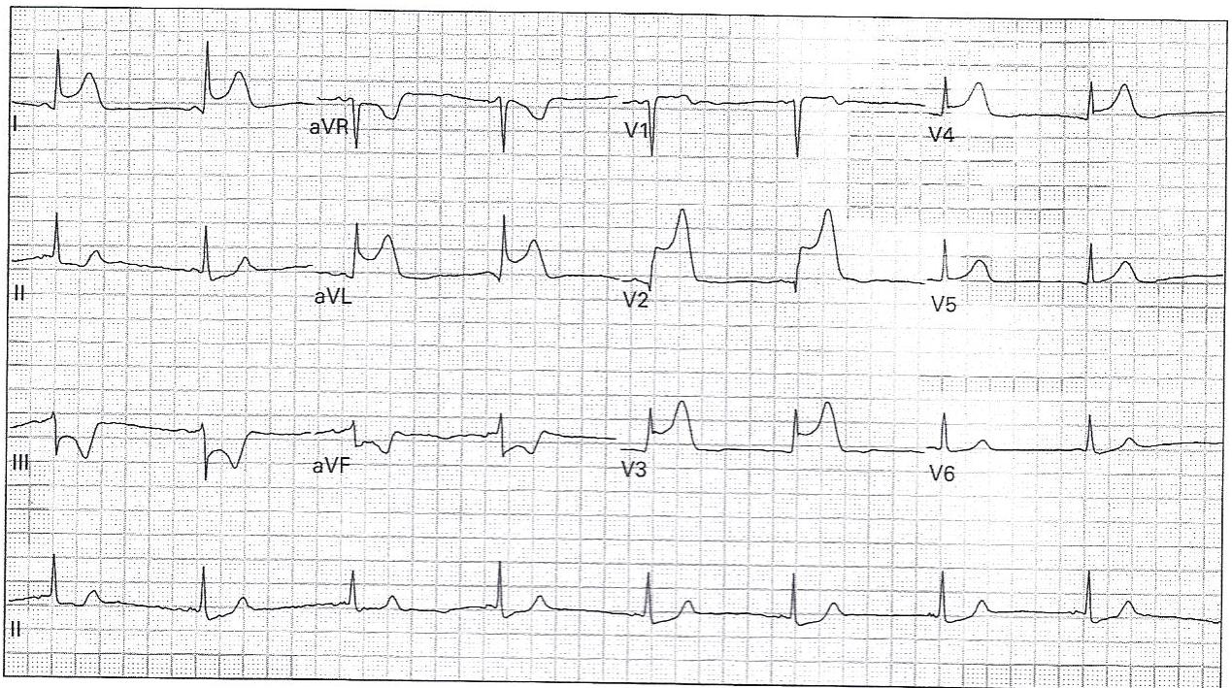

1. Please describe how to calculate/determine Rate, Rhythm, and Axis for this EKG
2. Is this a STEMI? If yes:
   1. Please describe/define why this EKG represents an STEMI.
   2. What type of STEMI is this (what area of the heart is affected)?
   3. What artery is most likely affected and why?
3. Please describe what intervention should be done in the Emergency Department (ED) for this patient, and what important non-ED intervention should be performed immediately.

Question 2:

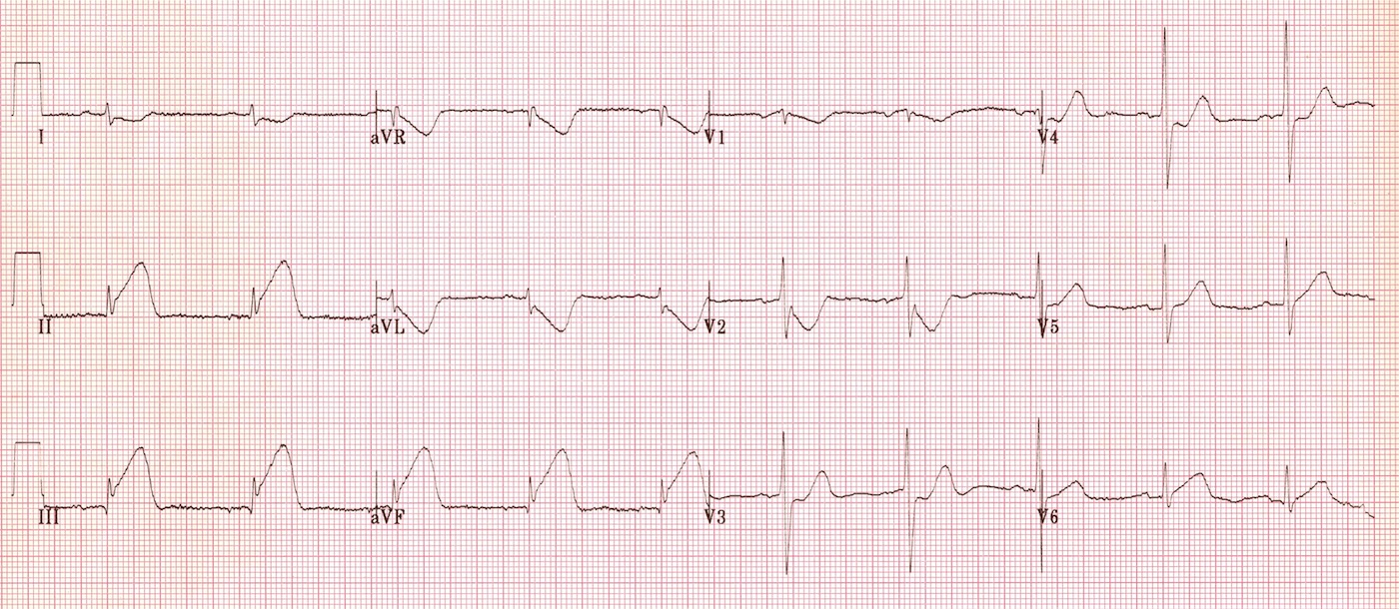

1. Is this a STEMI? If yes:
   1. Please describe/define why this EKG represents an STEMI.
   2. What type of STEMI is this (what area of the heart is affected)?
   3. What artery is most likely affected and why?
2. In addition to the above-mentioned area of injury, this EKG might also be concerning for another additional extension of the area of injury, that we should always be cautious of to identify.

* 1. How might we identify this additional area of injury (hint, using the EKG machine)?
  2. Why is identifying this additional area of injury important in terms of treatment (i.e. what common treatment should be avoided in these patients and what consequence may occur if it is given)?

Question 3

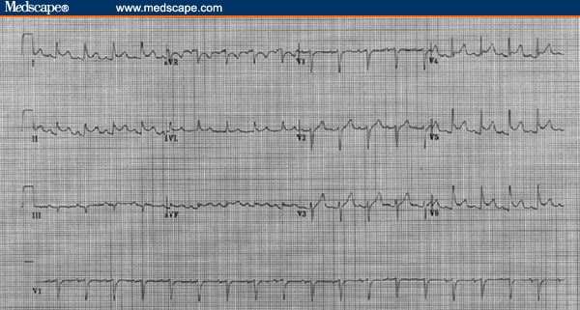

1. The above patient is from a young woman with an atypical story of chest pain. You notice some ST segment Elevations. Is this EKG concerning for a STEMI? If not, what other diagnosis (in the right clinical setting) might you consider from this EKG and why (i.e. describe the EKG findings of this diagnosis)?
2. If this non-STEMI diagnosis is considered in a healthy looking, possibly dischargeable patient, what other associated diagnoses must be ruled out first, which will increase mortality?
   1. How might you evaluate these associated diagnoses using findings in the above EKG?

* 1. What other lab or imaging tests might you order to help identify these associated diagnoses?

1. If this non-STEMI diagnosis is considered in a healthy looking, possibly dischargeable patient, what first-line treatment might this person be discharged on?

Question 4

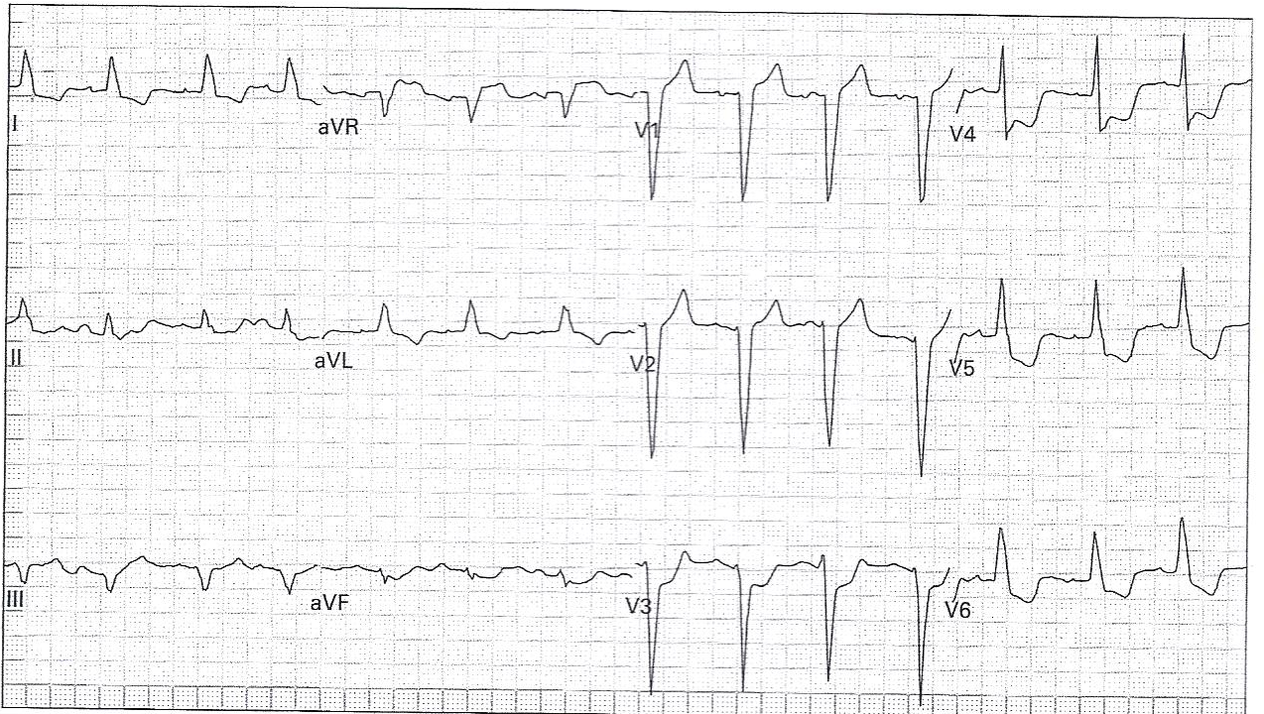

1. The above patient has an atypical presentation of chest pain. You notice some ST segment changes, but also notice that the QRS is widened. What is the underlying reason/diagnosis for why this EKG has a widened QRS and how might you identify it on this EKG?

1. In the above diagnosis, it is common to see some ST segment changes that are not indicative of ischemia/infarction.
   1. Please explain the concept/ term used to describe these ST segment changes, common in this diagnosis.
   2. What criteria has been commonly used to identify at what degree these ST segment changes qualifies as ischemic or not? Please describe how to use this criteria.

* 1. Using the above identified criteria, do you think that this EKG meets criteria for ischemia/infarction, or passes as non-ischemic?

Question 5

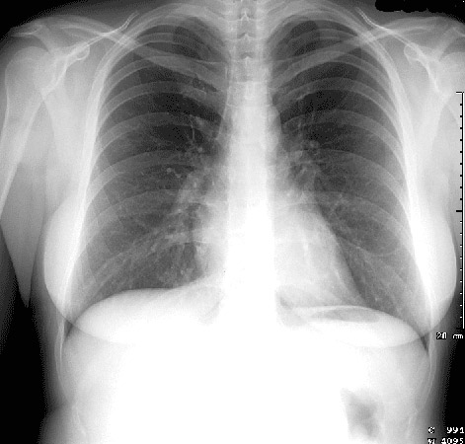

1. Please describe a systematic way (using a mnemonic) to read chest radiographies, using the above Chest XRAY as an example
2. What type of Chest XRAY is this (AP vs PA) and how can you tell?
3. Please draw on the above XRAY, identifying the following structures:
   1. Manubrium, Superior Vena Cava, Right Main Bronchus, Horizontal fissure, Right Atrium, Right and Left Oblique Fissures, Inferior Vena Cava, Diaphragm, Liver, Gastric bubble, Aortic Arch, Pulmonary Trunk, Left Main Bronchus, Left Atrium, Left Ventricle, Costo-phrenic angles

Question 6

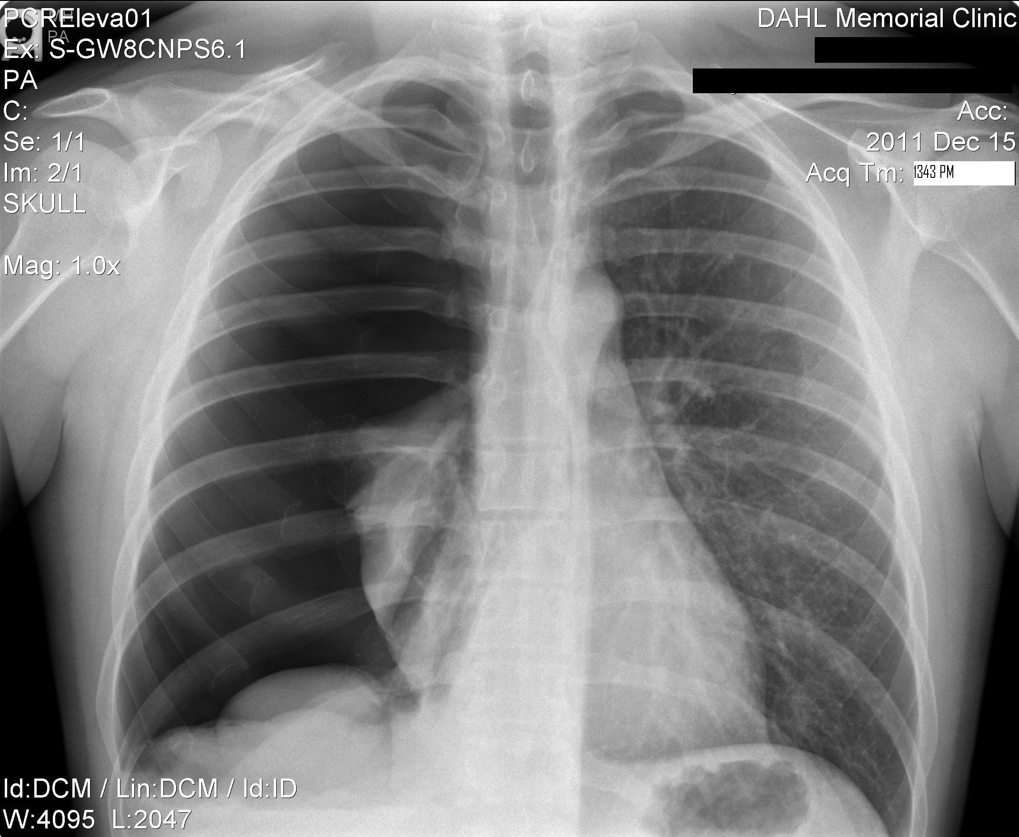

1. Please read this Chest XRAY using a systematic approach and diagnose the reason for this patient’s chest pain and shortness of breath.

1. What immediate, followed by more definitive intervention is warranted for this patient?

1. Give a reason why this diagnosis may occur spontaneously (non-traumatic).
   1. If occurring spontaneously and not as bad as in the above XRAY, what degree would not require the intervention suggested in B? If this degree of the diagnosis is seen, what other treatment modality might be attempted?
   2. What other imaging modalities can be used & when should you use them?