**Shock/Trauma CBL**

Case #1 (Trauma)

An 18 YOM is brought in by EMS after being hit in the head and the abdomen with a baseball bat. His eyes open to pain, he calls you and all the nurses “mama” and tries to grab anyone who walks by. When the medical student attempts to put in an IV, he swats them away. His vital signs are 80/40 P 130 RR 22 02 97% on room air. On primary survey you notice a scalp hetatoma with a small laceration and no obvious skull deformities and a rigid, distended abdomen that is tender when palpated.

1. What is this patient’s GCS? Do they need to be intubated now? (if not, might they need to be intubated later?)
2. What sorts of therapy can you offer the patient to improve their vital signs? List 3 therapies in the order in which you would give them and be specific.
3. What imaging is appropriate early on and with these current vital signs?
4. What is the patient’s problem list? What is your differential diagnosis?
5. What is the patient’s disposition?

Case #2 (Trauma)

A 72 YOF PMH diabetes, hypertension, and coronary artery disease with multiple stents is brought in by EMS after falling down a flight of stairs. She had a loss of consciousness and cannot recall events preceding the fall. Her GCS is 12. Her right leg is shortened and externally rotated and neurovascularly intact distally. She has no other signs of trauma. Her vital signs are 110/60 P 99 RR 24 02 96% on room air. She says her pain is 10/10.

1. What is the patient’s problem list? What is your differential diagnosis?
2. What laboratory tests and imaging studies are appropriate in this patient in the ER and why?
3. Arrange the following 5 actions in the order in which you would perform them:
   1. Call orthopedics
   2. Primary survey
   3. EKG, fingerstick, nasal cannula
   4. Obtain imaging
   5. Offer her pain medication
4. What questions do you have regarding medications she might be taking?
5. What is the patient’s disposition

Case #3 (Shock)

48 yo M with hx GERD, HTN presents with shortness of breath, chest pain, and dizziness which have slowly gotten worse over the past day. He reports having a cold last week with a nonproductive cough. The chest pain and shortness of breath are present at rest and the chest pain is worse when he leans forward. He has no family history of cardiac disease or early cardiac death. Vital Signs: afebrile, HR 115, BP 100/87, RR 24, Sat 96%. The patient appears to be in respiratory distress, but is mentating well, moist mucous membranes, distant heart sounds, mild JVD, bilateral crackles on lung exam, no abdominal tenderness.

1. What is the differential for this patient’s symptoms?
2. In what order should the following interventions/evaluations be done?
   1. CXR
   2. EKG
   3. Primary survey
   4. Ultrasound
   5. IV, O2, Monitor
3. Is this patient in shock? Should this patient get fluids?

Eventually, the astute physician did a RUSH exam, and found this with the ultrasound:

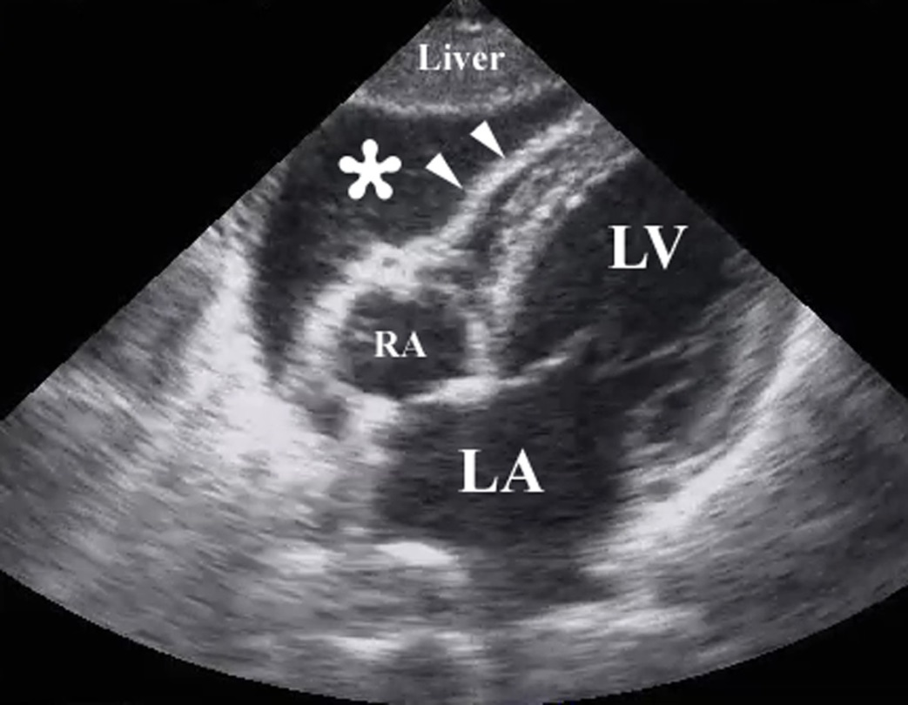

1. What is the diagnosis? What type of shock is this?
2. Should this patient get fluids now? What is the intervention?
3. What is the disposition?

**Case #4 (Shock)**

55yo quadriplegic M s/p MCV with C-spine injury, contracted limbs, PEG tube, and recurrent UTI’s on contact precautions presents from his nursing home for tachycardia and tachypnea since this morning. On arrival pt is confused (unclear mental status baseline) and unable to give a history other than mumbles or groans when you move or touch him. He is placed on the monitor and his HR is 125, RR 32, O2 sat 95%, BP 100/60. He is cachectic and all of his limbs are contracted, unable to be extended.

1. What should you do next?
2. You’re unable to get IV access in his hands or his feet as the patient is extremely dehydrated, what is your next step?
3. What are you looking for in your physical exam?
4. Is this patient septic? Is this patient in shock?
5. What labs do you want? Any special considerations in getting these labs? Imaging?

You place a foley to get urine studies and gross pus flows into the urine bag.

1. What are the two most important interventions to do next?
2. Are there special considerations with regards to antibiotics in this patient?
3. When would you consider starting this patient on vasopressors?