**Buprenorphine (Suboxone)**

**for Treatment of Opioid Problems**

**Need an appointment?**

**Call the Bellevue ER Health Coaches**

**718-245-2665**

What is buprenorphine?

Buprenorphine (BUP or “bupe”) is a medication that treats addiction to opioids such as prescription painkillers (like Vicodin, Oxycontin, or Percocet), heroin, and Fentanyl. One medication commonly used is **Suboxone**, but there are many others.

How does BUP work?

BUP stops withdrawal symptoms and cravings by acting on the same areas of the brain as the opioids you were taking. This makes it easier for you to cut down or even stop using, so that you can focus on other activities that are important to you. BUP is an opioid, but it is NOT the same as substituting one addictive drug for another. When used properly, BUP helps you feel normal, without feeling high, and does NOT create a new addiction.

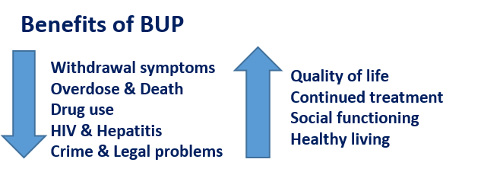How well does BUP work?

A person with addiction can regain a healthy, productive life. Treatment can help. Treatment that includes BUP is often the best choice for opioid addiction. BUP has been prescribed for over 15 years and studied even longer. It helps you get through withdrawal and cope with cravings. It gives you the chance you need to focus on getting back to healthy living.

Why can’t I quit “cold turkey”?

Addiction cannot be cured, but it can be effectively treated. Addiction is NOT a sign of weakness. It is difficult to stop using opioids after you have become addicted because the cravings are so strong and the fear of withdrawal is so great. Chronic drug use causes changes in the brain that put people at risk of relapse for weeks and months after stopping use. If you are like most people, you cannot walk away from addiction on your own. People who stop using opioids are extremely likely to return to use (“relapse”) and are at a very high risk of overdose and death when that happens. After you stop using opioids for a period of time (weeks or even days), a much smaller amount of opioid use can cause overdose death.

How do I take BUP or ‘Suboxone’

* BUP usually comes as a tablet or film that dissolves under the tongue in about 10 minutes.
* **You must let the medicine dissolve under your tongue.** Do not swallow it because it will not work. You may rinse the bitter taste from your mouth only after it is fully dissolved.
* **If you miss a dose:** Take a dose as soon as you remember. If it is almost time for your next dose, wait until then and take a regular dose. Do not take extra medicine to make up for a missed dose

Why must I be in withdrawal before starting BUP?

BUP replaces any other opioids (heroin, painkillers, methadone) in the brain. The effect of BUP is not as strong as these other opioids. If you take it before you are in withdrawal, the strong effect of the other opioids will go away suddenly and put you in withdrawal instantly. You can become very sick.

Why does the medicine have naloxone in it?

Naloxone is often in the medication to help prevent BUP abuse and addiction (for instance, the brand Suboxone has both BUP and naloxone (Narcan)). Naloxone will cause people to feel withdrawal symptoms if they inject their buprenorphine. As long as the medicine is taken under the tongue, the naloxone does not get absorbed.

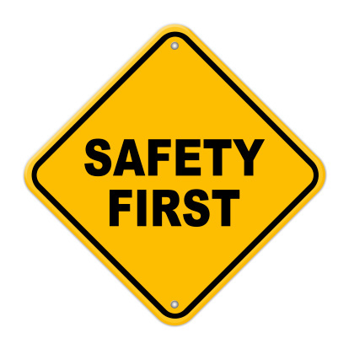

BUP Safety and Precautions

Tell your doctor about any medical problems you have and medications you take to avoid drug interactions or life-threatening medical problems. Ask your doctor and pharmacist about any questions you may have. See the instructions that come with your medication at the pharmacy for additional precautions and information.

* **Avoid withdrawal symptoms:**
  + Don’t start BUP until you are in withdrawal
  + Don’t inject or “shoot-up” BUP- it has naloxone in it
  + Don’t stop taking BUP suddenly
* **Avoid Overdose and Death**
  + The effect of heroin or prescription opioids will not have the same effect while you are taking this medication. Do not try to over-ride the effect by taking high doses of illicit or prescription opioids. You may overdose.
  + Don’t drink alcohol, use illegal drugs, or take sedatives, tranquilizers, or other drugs that slow breathing.
  + Don’t take ANY other medications unless your doctor says it’s OK. Sleep medications such as Ambien and anti-anxiety medications such as Valium and Xanax can be especially dangerous.
* **Keep yourself and others safe**
  + Lock up your medication away from children and pets. If a child accidentally takes some, get medical help fast. BUP can be fatal in children.Store the medicine in a closed container at room temperature, away from heat, moisture, and direct light.
  + Keep the medication in the bottle it came in.
  + Don’t share your medication with anyone.
  + BUP can make you feel drowsy at first; don’t drive a car or operate dangerous machinery until you know how BUP affects you.
* Nearly all drugs have **potential side effects**. The following are some potential side effects of BUP: constipation, nausea or vomiting, headache, sweating, mouth or tongue pain/numbness, heart palpitations, difficulty sleeping, lightheadedness, dizziness.
* **Serious Health Risks**
  + Slowed or shallow breathing, which can cause sudden death
  + Overdose risk when mixed with alcohol or sedatives or other drugs
  + Addiction if not taken as prescribed
  + Risks in those with severe lung, heart, liver disease
  + Liver problems (rare)
  + Let your doctor know if you are pregnant or breastfeeding.

**What to do in an emergency?**

* If people notice you have slowed breathing or problems waking up, they should call 911 and tell the emergency providers that you are taking BUP. They should **use a naloxone rescue kit** as indicated.
* Ask your doctor to prescribe a rescue kit with naloxone, which could save your life if you have an overdose.
* **Call 911 or your doctor or** **return to the ER right way** if you notice any of these side effects:

Call 911

* Allergic reaction: Itching or hives, swelling in your face or hands, swelling of your mouth or throat
* Trouble breathing or slow breathing

**Responding to an Overdose**

**1. Call 911**

**2. Give naloxone if you have it:** Spray naloxone into the nose. If there is no response in two minutes, give a second dose.

**3.** **Lay the person on his or her side. Wait for help to arrive.**

* Extreme dizziness or weakness, sweating, seizures, clammy skin
* Yellow skin or eyes, vomiting, stomach pain
* For less severe side effects, it is best to follow up with your doctor as soon as possible without stopping the medicine. You will experience withdrawal if you stop BUP suddenly.
* You may also call the **NYC Poison Center** at 1-800-222-1222 or 212-POISONS (212-764-7667) for advice or if you have questions about the medication or side effects.

What to expect at follow up appointment.

Your doctor may adjust your medication in order to reduce cravings. Talk with your doctor about your treatment goals. Your treatment plan often includes counseling, other services, and rules you must follow.



How long do I need to take BUP?

Everybody is different. Many people may benefit from a long-term treatment; your treatment goal will be discussed on an ongoing basis with your provider.

**Referrals:** Not all doctors can prescribe BUP.

BUP can only be prescribed by providers with a special license. Most Emergency Departments do not administer or prescribe BUP, and those that do have restrictions on how often they can give it.

If you need to find treatment for opioid use disorder or have mental health needs, see the resource list given to you in the Emergency Department. There are also free 24-hour-a-day, 365-day-a-year, helplines available in English and Spanish for individuals and family members facing mental and/or substance use disorders. They provide referrals to local treatment facilities, support groups, and community-based organizations for further treatment.

* **SAMHSA’s National Helpline, 1-800-662-HELP (4357)**
* **In New York, you may call 1-888-NYC-WELL (1-888-692-9355)**

**or 311 or the NYS OASAS HOPEline: 1-877-846-7369**

Counseling, Narcotics Anonymous (NA), Peer Support and Other Treatment

For many people, another important part of treatment for opioid use disorder is counseling or participation in 12-step programs or other behavioral treatment. Counseling provides the opportunity to talk with a professional either one-on-one or in a group with others who are in treatment. In 12-Step programs, like NA, people with substance use disorder meet with one another to support positive change and recovery from addiction.

Through counseling and other programs, you learn about the motivations and behaviors that led to your opioid addiction. You gain support and skills while working with others to manage your recovery long term. It can provide you with encouragement and motivation to stick to treatment. It can help you learn how to make healthy decisions, handle setbacks and stress, and move forward with your life.

* Narcotics Anonymous (NA): www.nycna.org or 212-929-6262
* See referral information above for assistance locating a counselor