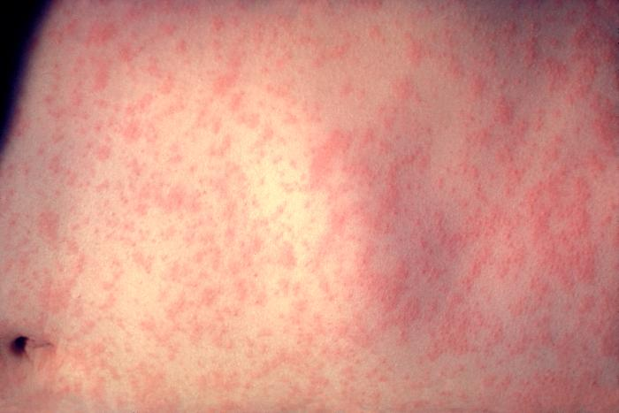http://phil.cdc.gov/phil/details.asp?pid=3168

Immunizations not up to date?

A 2 year-old boy presents to your ED with a history of 7 days of tactile temperatures and a rash. The rash started on day 3 of fever and has spread to the whole body. The child is from the Caribbean and has not received any vaccines since six months of age. The child has been healthy otherwise. They came to your ED for further evaluation. Vitals in the ED are within normal limits. Exam is significant for the rash above, erythematous pharynx, slightly injected conjunctivae. There is no murmur, no abdominal masses, and the child is non-toxic appearing.

Upon seeing this rash, what should be included in your differential?

Dengue Fever

Measles

Kawasaki’s Disease

Group A strep (less likely)

Other viruses including Coxsackie

Drug Reaction

What is the most likely diagnosis given the history above?

Measles

What do you need to know about Measles as the ED physician….

1. The vaccine is typically given in the US at age 12 months. It can be given at 6 months but this is not usual.
2. The 3 C’s- Cough/Coryza/Congestion. . . This is the prodrome- will occur before the rash starts and can continue for 7-8 days and usually is accompanied by high fevers
3. Koplik spots: they were not seen in this child’s mouth. If the child has the rash, you will not see them. They occur in the usually prior to the rash and last about 36-72 hours. They usually along the buccal mucosa and are red spots with whitish/bluish centers.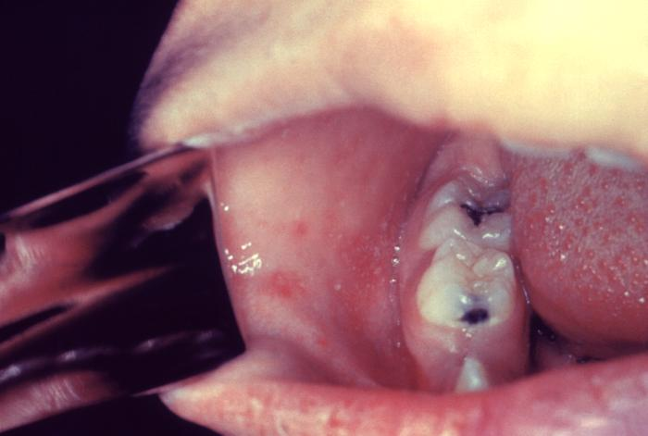
4. The RASH: Starts on head and usually spreads downward- sparing the palms and soles. It fades in the same direction. Usually starts in the middle of the course and pharyngitis and fever can accompany this rash.