Pelvic fracture + Hemodynamic Instability = YIKES…read below.

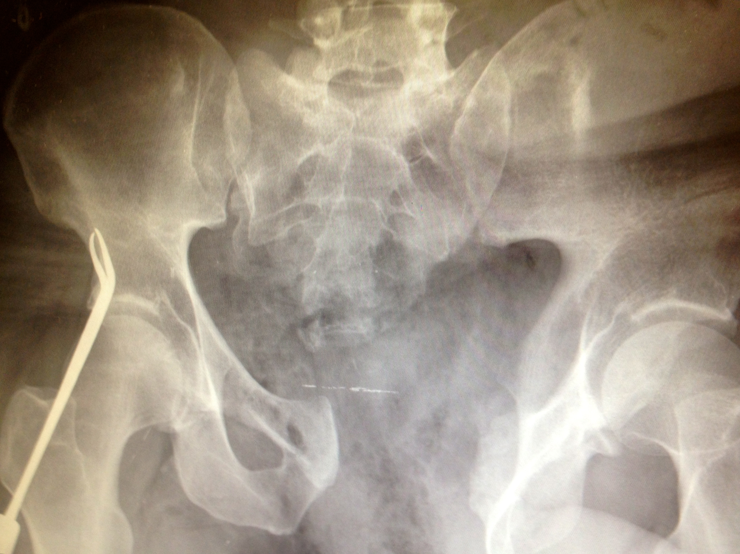

Hemodynamically unstable pelvic fractures have mortality rates upwards of 45-50%. Death in the first 24 hours is generally from acute blood loss. These injuries need to be taken seriously; immediate and urgent resuscitation and stabilization is warranted. The main points in managing these cases are resuscitation while simultaneously identifying the source of bleeding and controlling it.

As far as resuscitation is concerned, a few key points to remember.

1. Aggressive volume repletion: activate massive transfusion protocol

- Keep in mind with massive transfusions, the trend is towards a 1:1 ratio of pRBCs to FFP, followed by platelets after every 5-10 units pRBCs to start, with the ratio approaching 1:1:1 as transfusion continues (that is, pRBC : FFP : Platelets).

- Fluids should be warmed to achieve normothermia, as hypothermia induces a coagulopathic state, further delaying hemostasis.

2. Controlling the bleeding

- Pelvic compression has been noted to decrease the pelvic volume by 10%, level III evidence supports that this is significant for control of hemorrhage with one study finding a decrease in transfusion requirements from on average 17 units to 5 units pRBCs.

- You can use a tightly wrapped sheet or a pelvic orthotic device if available: sheets are very effective if used properly. You should first fold the sheet into a band with a width of 12 inches, no greater. Place a sheet under the legs and work your way up to the pelvis. The sheet should be centered around to the greater tronchanters and then bound tightly.

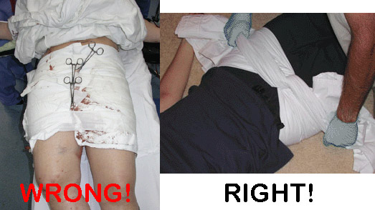

<http://24.media.tumblr.com/tumblr_lq1qjt4jBK1qafl51o1_1280.jpg>

3. The patient does not leave your ER for ANY imaging. Bedside FAST and AP pelvic XRay are both very important.

There are 3 major sources of bleeding in the pelvis: arteries and veins that traverse the pelvis as well as cancellous bone. Vessels are contained between the peritoneum and the musculoskeletal structure of the pelvis. Once this is insulted, hemorrhage is very difficult to control. Most arterial bleeding occurs from the internal iliac arteries, confirmed in a seminal study from 1973 in which 23 of 27 autopsies revealed bleeding from internal iliac arteries. Bleeding was bilateral in 63%. However, studies have found that ligating both IIAs only decreased pressure of distal arteries by 24%. This is due to the impressive collateral arterial supply present in the pelvis.

Ultimately the bleeding will have to be controlled by either IR via angiographic embolization or in the OR via prepelvic packing. In one retrospective analysis, researchers looked at outcomes from angiography suite vs OR. Patients were ultimately found to have a lower mortality if they were taken to the OR first, followed by angio if pelvic bleeding was not controlled versus if they were taken to angio followed by OR. This is likely due to the presence of other intra-abdominal injuries and therefore sources of bleeding—up to 55% of patients who have pelvic ring injury will have concomitant abdominal trauma that cannot be ignored. So here’s where the FAST comes in. If the FAST is positive, dispo is to OR. If the FAST is negative, IR for angio is recommended.

In summary, the algorithm by Western Trauma Association:

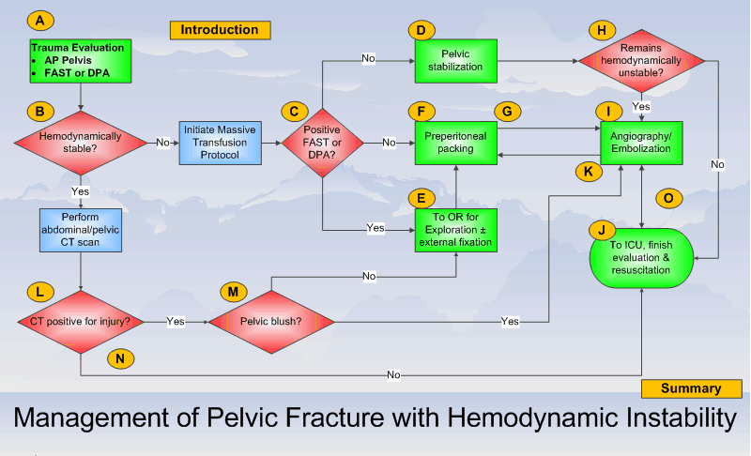

http://www.westerntrauma.org/algorithms/WTAAlgorithms_files/gif_2.gif

References:

G Poole et al. Pelvic fracture from major blunt trauma. Outcome is determined by associated injuries. Ann Surg. 1991 June; 213(6): 532-539

Burlew CC et al. Preperitoneal pelvic packing/external fixation with secondary angioembolization:optimal care for life-threatening hemorrhage from unstable pelvic fractures. J Am Coll Surg. 2011 Apr; 212(4): 628-35.

Smith W. Operating room or angiography suite for hemodynamically unstable pelvic fractures? J Trauma 2012 72(2): 364-372.

Smith W. Early predictors of mortality in hemodynamically unstable pelvis fractures. J Orthop Trauma 2007;21:31-37.

Emergent pelvic fixation in patients with exanguinating pelvic fractures. J Am Coll Surg. 2007 204:935-942